**Date: 04th November 2024**

**To,**

**The General Manager**

**Listing Department**

**BSE Limited Phiroze Jeejeebhoy Towers,**

**Dalal Street, Mumbai - 400 001.**

**Maharashtra, India.**

**Scrip Code: 540221, Stock Symbol – Shashank**

**Subject: Intimation of Board meeting for considering and approving the Unaudited Standalone Financial Results for the quarter Half and Year Ended September 30, 2024**

**Ref.: Regulation 29 (1) (a) of SEBI (LODR) Regulations, 2015**

**Dear Madam/Sir**,

pursuant to Regulation 29(1)(a) of SEBI (Listing Obligations and Disclosure Requirements) Regulations, 2015 ('Listing Regulations'), we wish to inform you that the meeting of the Board of Directors of the Company is scheduled to be held on **Friday, November 08, 2024** to consider inter-alia among other items, the Unaudited Standalone Financial Results of the Company for the quarter and half year ended September 30, 2024.

Further to note that the intimation regarding closure of Trading Window for dealing in the securities of the Company is already provided to the Stock Exchanges.

Kindly take the same on records.

Yours Faithfully,

**FOR AND ON BEHALF OF**

**SHASHANK TRADERS LIMITED**

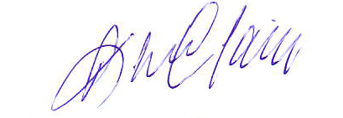

**Praveen Jain**

**Managing Director**

**DIN- 01776424**